Asymmetric DCC correlation: USDJPY and EURGBP
Method 10 / GARCH(1,1) + Cappiello-Engle-Sheppard ADCC / Alpari D1 full available history

Study setup
Logical pair: USDJPY , EURGBP
Broker symbols: USDJPY_i , EURGBP_i
Snapshot: 2026-11-03_majors_alpari_D1
Timeframe: D1
Matched return window: 1999-01-06 to 2026-11-02 (UTC bar dates)
Matched return count n: 7181
Dropped unfinished last bar dated 2026-11-03 UTC after a tick-volume check against the prior complete day.
USDJPY GARCH(1,1): mu=0.000111, omega=0.005055, alpha=0.052196, beta=0.935005
EURGBP GARCH(1,1): mu=-0.000020, omega=0.000650, alpha=0.046425, beta=0.951941
ADCC: a=0.013085, b=0.979315, g=0.000000, a+b+g/2=0.992400
Nested DCC (g=0): a=0.013085, b=0.979315
Negative shock: n = min(z, 0) in broker quote direction (not inverted)
Burn-in ignored in path summaries and chart: first 60 updates
Complete matched rows (Excel): USDJPY-EURGBP_ADCC_D1.xlsx
Complete matched rows (HTML table): USDJPY-EURGBP_ADCC_D1_data.html

Method carried forward
Asymmetric DCC extends Engle DCC with an extra term on joint negative standardised shocks. Each matched daily log return of close, ln(close_t / close_t-1), is first filtered by a constant-mean GARCH(1,1). Then z = residual / sigma and n = min(z, 0). The Cappiello-Engle-Sheppard recursion uses A = (1-a-b) Q_bar - g N_bar with N_bar = mean(n n'). Quotes are not inverted, so a negative shock is a negative log return in the broker quote. Nested symmetric DCC (g = 0) is fit on the same z path for comparison. Constraints: a,b,g >= 0 and a + b + g/2 < 1. Path summaries ignore the first 60 updates. The headline is latest ADCC rho. Pearson r is a side check only. This is not a cause, lead, or trading signal.

Results
Latest ADCC rho: -0.005926
Latest nested DCC rho: -0.005926
Post-burn-in ADCC path (n=7121): mean=-0.111412, median=-0.113236, min=-0.493168, max=0.302744, std=0.114948
Share of post-burn-in days with |rho| >= 0.4: 0.72%; |rho| >= 0.7: 0.00%
Same-sample Pearson r: -0.127992
ADCC minus r: 0.122067
ADCC minus nested DCC: 0.000000

Conclusion
Over 7181 matched daily log-return rows for USDJPY and EURGBP (broker quote directions unchanged), latest ADCC rho is -0.0059 (negative, weak conditional linear link in this sample) with fitted a=0.0131, b=0.9793, g=0.0000. Nested symmetric DCC latest rho is -0.0059 (ADCC minus DCC = 0.0000). After a 60-day burn-in, path mean is -0.1114 and std is 0.1149. Same-sample Pearson r is -0.1280 (ADCC minus r = 0.1221). This does not establish cause, lead-lag, or a lasting trading rule.

Charts
Daily closes

Daily log returns
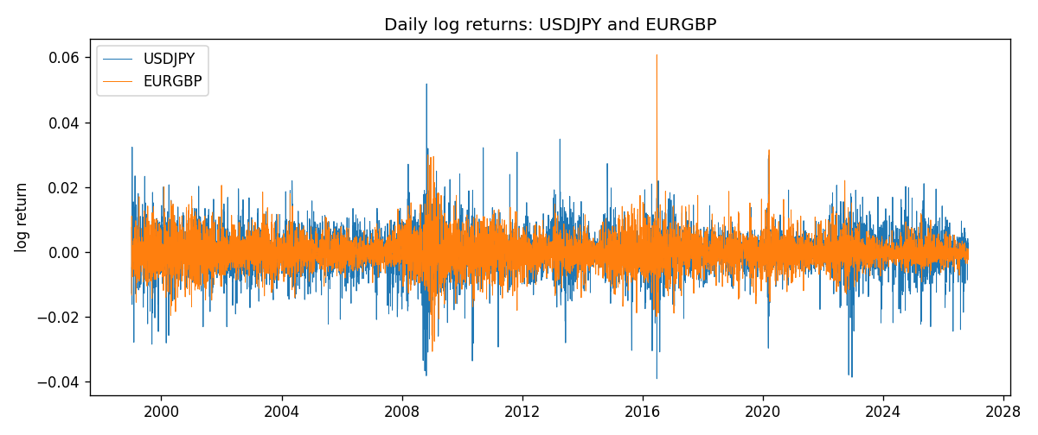
ADCC rho path with nested DCC and Pearson r
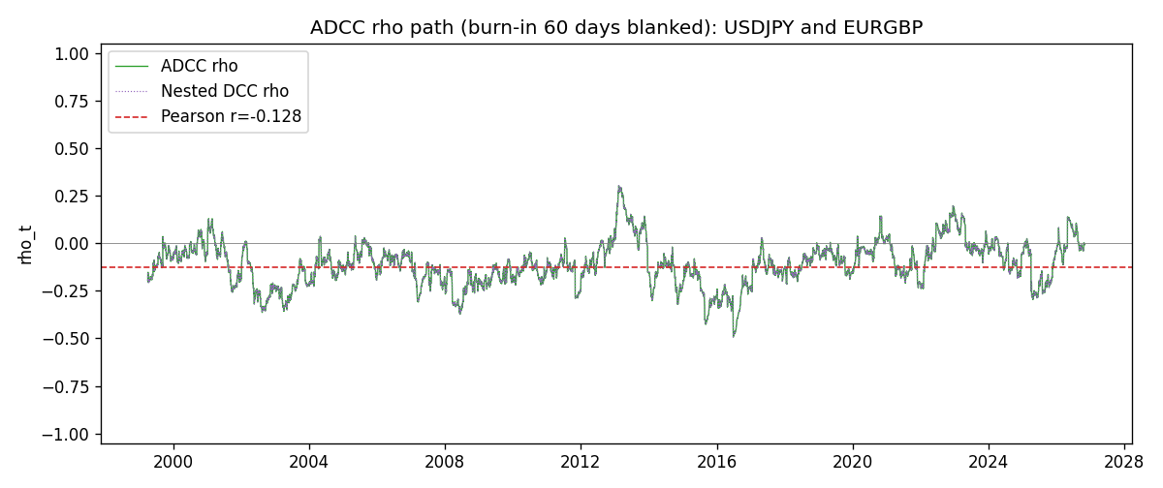

Data report
Every matched row that entered the ADCC recursion is stored in the sibling Excel workbook named USDJPY-EURGBP_ADCC_D1.xlsx. Embedding all rows as a Word table is impractical at this length; the Word file holds the column list, column summaries, and the first and last 15 matched rows.
Columns: time, USDJPY_open, EURGBP_open, USDJPY_high, EURGBP_high, USDJPY_low, EURGBP_low, USDJPY_close, EURGBP_close, USDJPY_tick_volume, EURGBP_tick_volume, USDJPY_spread, EURGBP_spread, USDJPY_real_volume, EURGBP_real_volume, USDJPY_log_return, EURGBP_log_return, USDJPY_sigma, EURGBP_sigma, USDJPY_z, EURGBP_z, USDJPY_n, EURGBP_n, q11, q22, q12, rho_adcc, rho_dcc
Column summaries (matched calculation rows)
column | count | mean | std | min | 25% | 50% | 75% | max
USDJPY_open | 7181 | 113.80773 | 19.228846 | 75.693 | 104.38 | 110.98 | 120.71 | 163.824
EURGBP_open | 7181 | 0.78701429 | 0.09663819 | 0.5734 | 0.6877 | 0.83392 | 0.86523 | 0.9769
USDJPY_high | 7181 | 114.30513 | 19.290536 | 76.001 | 104.865 | 111.439 | 121.27 | 163.978
EURGBP_high | 7181 | 0.79009197 | 0.09701345 | 0.5789 | 0.6897 | 0.83701 | 0.8681 | 0.9799
USDJPY_low | 7181 | 113.28458 | 19.156841 | 75.402 | 103.87 | 110.53 | 120.172 | 163.628
EURGBP_low | 7181 | 0.78431381 | 0.09645598 | 0.5682 | 0.6857 | 0.83166 | 0.86287 | 0.9661
USDJPY_close | 7181 | 113.82069 | 19.244339 | 75.811 | 104.38 | 111.015 | 120.695 | 163.851
EURGBP_close | 7181 | 0.78705735 | 0.09663932 | 0.5735 | 0.6878 | 0.83401 | 0.86539 | 0.977
USDJPY_tick_volume | 7181 | 106398.86 | 179473.16 | 149 | 9958 | 53207 | 92916 | 1803508
EURGBP_tick_volume | 7181 | 87156.048 | 145513.65 | 154 | 6593 | 44384 | 81451 | 1424684
USDJPY_spread | 7181 | 20.250104 | 17.60648 | 0 | 6 | 11 | 30 | 50
EURGBP_spread | 7181 | 21.316669 | 19.115948 | 0 | 4 | 13 | 40 | 50
USDJPY_real_volume | 7181 | 3.4800425e+10 | 1.6097887e+11 | 0 | 0 | 0 | 0 | 3.8834203e+12
EURGBP_real_volume | 7181 | 2.788005e+10 | 1.3523257e+11 | 0 | 0 | 0 | 0 | 3.5726265e+12
USDJPY_log_return | 7181 | 4.847e-05 | 0.00620794 | -0.03908203 | -0.00320533 | 0.00011473 | 0.00340924 | 0.05184024
EURGBP_log_return | 7181 | 2.133e-05 | 0.00487349 | -0.03067367 | -0.00262366 | -0.00010035 | 0.00255918 | 0.06075387
USDJPY_sigma | 7181 | 0.00599431 | 0.00174469 | 0.00337606 | 0.00477562 | 0.00569459 | 0.00679304 | 0.0188441
EURGBP_sigma | 7181 | 0.00463639 | 0.00169659 | 0.0018553 | 0.00343258 | 0.00442387 | 0.00553578 | 0.01546722
USDJPY_z | 7181 | -0.00896678 | 1.0002576 | -6.5267155 | -0.56460533 | 0.00046376 | 0.58097618 | 7.1025632
EURGBP_z | 7181 | 0.00758224 | 1.0000697 | -3.7915926 | -0.62185841 | -0.02014422 | 0.59704829 | 8.4809388
USDJPY_n | 7181 | -0.37435094 | 0.62366959 | -6.5267155 | -0.56460533 | 0 | 0 | 0
EURGBP_n | 7181 | -0.3796189 | 0.56996928 | -3.7915926 | -0.62185841 | -0.02014422 | 0 | 0
q11 | 7181 | 1.0008356 | 0.13676502 | 0.66775367 | 0.91276677 | 0.99815115 | 1.0785836 | 1.5719468
q22 | 7181 | 1.0013698 | 0.11435176 | 0.76219679 | 0.92664812 | 0.99016937 | 1.058275 | 2.0749022
q12 | 7181 | -0.11341574 | 0.12561295 | -0.86246877 | -0.17929184 | -0.10980772 | -0.03845357 | 0.3883974
rho_adcc | 7181 | -0.11174027 | 0.11454821 | -0.49316833 | -0.18156665 | -0.11394033 | -0.04026142 | 0.30274435
rho_dcc | 7181 | -0.11174027 | 0.11454817 | -0.49316842 | -0.18156663 | -0.11394035 | -0.04026153 | 0.30274434
First 15 matched rows (selected columns)
time | USDJPY_log_return | EURGBP_log_return | USDJPY_z | EURGBP_z | USDJPY_n | EURGBP_n | q11 | q22 | q12 | rho_adcc | rho_dcc
1999-01-06 | 0.0075660159 | -0.013303338 | 0.64300364 | -2.3699129 | 0 | -2.3699129 | 1 | 1 | -0.11261682 | -0.11261682 | -0.11261682
1999-01-07 | -0.012851583 | 0.011051402 | -1.140959 | 1.7920974 | -1.140959 | 0 | 0.99232527 | 1.0604049 | -0.13108241 | -0.12778549 | -0.12778549
1999-01-08 | -0.0047719894 | -0.004943862 | -0.42834572 | -0.75904295 | -0.42834572 | -0.75904295 | 0.99643279 | 1.0880936 | -0.15598113 | -0.14980107 | -0.14980109
1999-01-11 | -0.016195423 | -0.0012752393 | -1.4687112 | -0.19547916 | -1.4687112 | -0.19547916 | 0.98582274 | 1.0807254 | -0.14935637 | -0.14469937 | -0.14469939
1999-01-12 | 0.032310364 | 0.0033970309 | 2.8279214 | 0.54426645 | 0 | 0 | 1.0012564 | 1.066471 | -0.14336625 | -0.13873938 | -0.1387394
1999-01-13 | 0.0081373171 | 0.00042381861 | 0.60526106 | 0.071832273 | 0 | 0 | 1.0927852 | 1.0558875 | -0.1211176 | -0.11275376 | -0.11275376
1999-01-14 | 0 | -0.0019793588 | -0.0085799846 | -0.32497055 | -0.0085799846 | -0.32497055 | 1.0825747 | 1.0417144 | -0.11889933 | -0.11196342 | -0.11196342
1999-01-15 | 0.0055343401 | -0.0076715819 | 0.431643 | -1.2960013 | 0 | -1.2960013 | 1.0677831 | 1.0291487 | -0.11725935 | -0.11185796 | -0.11185796
1999-01-18 | 8.7600193e-05 | 0.00071280921 | -0.001937587 | 0.12213894 | -0.001937587 | 0 | 1.0557343 | 1.0374384 | -0.12300944 | -0.11753845 | -0.11753845
1999-01-19 | -0.0056219403 | -0.0014261269 | -0.48384165 | -0.24004168 | -0.48384165 | -0.24004168 | 1.0414969 | 1.0237746 | -0.12132402 | -0.11749399 | -0.11749398
1999-01-20 | -0.0053879917 | 0.0019960086 | -0.47594816 | 0.35176355 | -0.47594816 | 0 | 1.030617 | 1.0109521 | -0.11815069 | -0.11575035 | -0.11575035
1999-01-21 | 0.0084664056 | -0.00071240297 | 0.74165557 | -0.1233994 | 0 | -0.1233994 | 1.0198632 | 0.99926003 | -0.11875332 | -0.11763473 | -0.11763473
1999-01-22 | 0.0060412564 | -0.0017118406 | 0.53509597 | -0.30850718 | 0 | -0.30850718 | 1.0135649 | 0.98638998 | -0.11835035 | -0.11836394 | -0.11836394
1999-01-25 | -0.0073594164 | -0.0054402425 | -0.69016558 | -1.0094163 | -0.69016558 | -1.0094163 | 1.0039462 | 0.97483224 | -0.11891823 | -0.12020658 | -0.12020658
1999-01-26 | 0.0012303367 | -0.00057438255 | 0.1052823 | -0.10321652 | 0 | -0.10321652 | 0.99701254 | 0.97560041 | -0.10819876 | -0.10970741 | -0.1097074
Last 15 matched rows (selected columns)
time | USDJPY_log_return | EURGBP_log_return | USDJPY_z | EURGBP_z | USDJPY_n | EURGBP_n | q11 | q22 | q12 | rho_adcc | rho_dcc
2026-10-13 | -0.0018932826 | 0.00020130374 | -0.41167935 | 0.10976961 | -0.41167935 | 0 | 1.0157902 | 0.81107716 | -0.034273145 | -0.037759032 | -0.037759126
2026-10-14 | 7.5800166e-05 | 0.0011241873 | -0.0074212015 | 0.57731479 | -0.0074212015 | 0 | 1.0045966 | 0.80205802 | -0.035011403 | -0.039004146 | -0.039004239
2026-10-15 | -0.0018524319 | -0.00087557391 | -0.41960112 | -0.43546241 | -0.41960112 | -0.43546241 | 0.99141763 | 0.79742878 | -0.035199159 | -0.039587495 | -0.039587586
2026-10-16 | -0.00037976126 | -0.0020380844 | -0.10668807 | -1.0386501 | -0.10668807 | -1.0386501 | 0.98081429 | 0.79101549 | -0.032936145 | -0.037392704 | -0.037392795
2026-10-19 | 0.0034946841 | -0.00056950988 | 0.75044111 | -0.28024764 | 0 | -0.28024764 | 0.96827547 | 0.79636925 | -0.031660841 | -0.03605502 | -0.036055109
2026-10-20 | -0.0022546642 | -0.0035906254 | -0.52761433 | -1.845731 | -0.52761433 | -1.845731 | 0.96321582 | 0.78852433 | -0.034613656 | -0.039717154 | -0.039717243
2026-10-21 | -0.00032883504 | -0.00140647 | -0.099418119 | -0.67505806 | -0.099418119 | -0.67505806 | 0.95453454 | 0.82438967 | -0.022011338 | -0.02481329 | -0.02481338
2026-10-22 | -0.0085942669 | -0.0018743924 | -2.0055936 | -0.90807094 | -2.0055936 | -0.90807094 | 0.94251969 | 0.8209002 | -0.021533789 | -0.024481051 | -0.024481139
2026-10-23 | 0.00035080446 | 0.00082421033 | 0.050972096 | 0.41198806 | 0 | 0 | 0.98325566 | 0.82230969 | 0.0018857074 | 0.0020971204 | 0.0020970294
2026-10-26 | 0.0041238746 | 0.00013133309 | 0.87247469 | 0.074658685 | 0 | 0 | 0.9705514 | 0.81512145 | 0.0012655824 | 0.0014228856 | 0.0014227953
2026-10-27 | 0.0027651658 | -0.0019957343 | 0.57743715 | -0.99278731 | 0 | -0.99278731 | 0.96803608 | 0.80593393 | 0.0012358115 | 0.0013991257 | 0.0013990368
2026-10-28 | -0.00095679538 | 0.00066967224 | -0.23519909 | 0.34393048 | -0.23519909 | 0 | 0.95997549 | 0.80976005 | -0.0071466853 | -0.0081058099 | -0.0081059017
2026-10-29 | -0.00038043789 | -0.0011722209 | -0.11037759 | -0.58274127 | -0.11037759 | -0.58274127 | 0.9484426 | 0.80215825 | -0.0089131951 | -0.010218752 | -0.010218844
2026-10-30 | -0.0010596481 | -0.0024205543 | -0.2681004 | -1.2235528 | -0.2681004 | -1.2235528 | 0.93658385 | 0.7976093 | -0.0087431009 | -0.010115726 | -0.010115817
2026-11-02 | 0.0026438521 | 0.00089940465 | 0.59019551 | 0.45967691 | 0 | 0 | 0.92575148 | 0.8082998 | -0.0051259373 | -0.0059257025 | -0.0059257929

